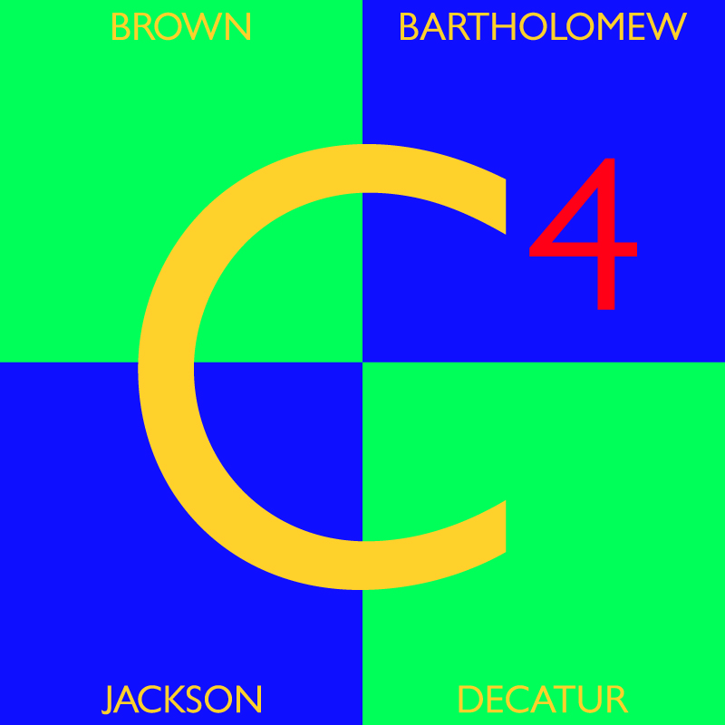

C⁴ Columbus Area
Career Connection

1-Year Follow-Up
Study

CLASS OF 2011

Teresa L. Weichman
July, 2012
C⁴ Columbus Area Career Connection
2010 - 2011 One-Year Follow-Up Study

The local One-Year Follow-Up Study of the class of 2010-2011 reports the status of 376 of the 394 exiting seniors who completed C⁴ programming their senior year of high school. This 95 percent return confirms that the findings in this study present a reliable and accurate status of each student. The findings, as detailed in this document, confirm the effectiveness of the education C⁴ provides each student in that they completed their C⁴ class, graduated from high school, continued their education and secured a higher wage from training-related employment.

C⁴ continues to meet the challenge of completing two follow-up studies involving two different sets of students. The local C⁴ study cohort includes a graduating class of students who were enrolled in a multiple-hour C⁴ Career & Technical Education (CTE) class during their senior year, thus showing the impact teachers, staff and programming have on C⁴ student success. By contrast, the State study includes the senior class of students who took at least six credits in CTE during the course of high school, not necessarily during their senior year, and not all CTE credits necessarily from C⁴ or the Area CTE District (District #41). This scattered group complicates the ability to make contact. To add to the challenge, C⁴ is unaware of the actual number of students included in the State study. C⁴ is only provided names of students (256) the State has no means of tracing using social security numbers or students who are involved in activity outside the State of Indiana. C⁴ participates in the State study solely to ensure that the required Placement Core Indicator is met.

It came as no surprise that contacting students was once again extremely difficult. While accurate and reliable, some information came from teachers, family members or social media, leaving some information unavailable such as satisfaction with C⁴ and hourly wages earned. In comparing this information with previous years, the variance is insignificant to the results. There has always been reluctance in reporting wages, and that continues to hold true. One could deduce that satisfaction, while very abstract, could come from the connection between training related figures for employment and education. Overall, 75 percent of the C⁴ Class of 2011 was engaged in training related activities which could infer satisfaction, and certainly supports the effectiveness of C⁴ education.

Our vision states that “C⁴ will connect community resources to provide career education for all students while laying the foundation for life-long learning.” The results of this study are found to be highly reflective of the total class, due to the 95 percent return rate.

C⁴ has chosen to view follow-up statistics by Clusters. This view provides a more focused perspective and promotes program improvement through teams developed to deliver connected occupational training. Clusters will compile trend data to enable teams to set goals for improvement and monitor achievement.

As a result, the information gained from respondents of the Class of 2011 is shared in the statistical review of the findings and recommendations that follow:

In terms of Employment . . . (See Employment chart and graphs, pages 11, 12, 19, 22, 23 & 24)

. . . 65% Employed, of which
53% Full-time
33% Part-time
8% Military
5% Stay-at home parent

. . . 50% of the respondents are employed in C⁴ Training Related positions.

In terms of Education . . . (See Education chart & graphs, pages 13, 14, 15, 17, 18, 19, 20, 21 & 24)

. . . 99% Graduated, earning
16% General Diploma
66% Advanced Core 40/Core 40 Diploma
7% Academic Honors Diploma
7% Technical Honors Diploma
3% Both Technical & Academic Honors Diplomas
1% Certificate of Completion

. . . 55% Continuing Education, of which
59% Four-Year Colleges/Universities.
38% Two-year Associate Degree.
3% Trade/Technical or Business Schools.

. . . 73% are continuing their education in C⁴ Related areas of study.

Wage Statistics (See Wage chart & graphs, pages 11 & 12)

At the time of this study, the minimum wage was $7.50 per hour. Of those who reported wages on this study, C⁴ learned that:

The Training Related Wage averaged $10.74 per hour
The Non-Training Related Wage averaged $8.05 per hour.

The Training Related wage is $3.24 above minimum wage, and
$2.69 more than those who earned wages
from non-training-related employment.

NOTE:
A breakdown of Follow-Up information from
Area 41 Schools can be found on Pages 25 – 29.

Review of Findings

- The 95 percent return rate confirms that the findings in this study present a reliable and accurate status of each student. Additionally, this return rate confirms the effectiveness of the education C⁴ provides each student in that they completed their C⁴ class, graduated from high school, continued their education and secured a higher wage from training-related employment. This return rate is just under the record return of 97 percent set in the study of the Class of 2010.

- The graduation rate for the class of 2011 is remarkable at 99 percent. Indiana is now a waivered State for No Child Left Behind (NCLB). While the changes associated with the waiver are still unclear, for the purpose of this study, the graduation rate includes all students who earned a work-based readiness waiver, certificate of completion, GED or any State-recognized diploma.

- The total of respondents employed continues to decrease slightly each year. This study saw a decrease from 74 percent from the class of 2010, to 65 percent, with the number of respondents employed in a training related position remaining steady at 50 percent.

- Continuing education saw a slight decrease from 62 percent to 55 percent, likely due to the increased cost of higher education and the stiff regulations for borrowing. Despite the slight decrease in students continuing their education, it is impressive to note that 73 percent of those continuing their education are enrolled in higher education programs related to the C⁴ CTE area of study. That is a 5 percent increase and just 7 percent under the highest training related statistic of 80 percent. C⁴ graduates are receiving valuable training in high school which enables them to carry on their education by connecting them to post-secondary schools to continue their C⁴ training.

- C⁴ awards more dual credit than any other school in Area District #41. It is therefore, not surprising to note that 62 percent of the respondents earned dual credit from their C⁴ class.

- Military enlistment remains steady at 8 percent, with 27 percent of law enforcement students choosing that career path. It should be noted that the 90 percent of all students enlisted in Military service are utilizing their training earned from C⁴.

- The training related wage averaged at $10.74 per hour, increased $0.51 from the previous year’s results. The minimum wage at the time of this study was $7.50, making the average wage $3.24 above the minimum. Overall, the training related wage is $2.69 higher than the average non-training related wage of $8.05. This confirms that C⁴ education develops graduates who are worthy of earning competitive wages. The gap between the Training-Related wage and the Non-Training-Related wage continues to widen in spite of the state of our economy.

- This is the tenth year for this study to assess overall satisfaction and benefit of taking a C⁴ program. On a scale of one to five, with five being the highest, respondents ranked their satisfaction with C⁴ education at 4.535. While accurate and reliable, some information obtained for this study came from teachers, family members or social media, leaving some data unavailable such as satisfaction with C⁴ and hourly wages earned. In comparing this information with previous years, the variance is insignificant to the results. There has always been reluctance in reporting wages, and that continues to hold true. One could deduce that satisfaction, while very abstract, could come from the connection between training related figures for employment and education. Overall, 75 percent of the C⁴ Class of 2011 was engaged in training related activities which could infer satisfaction, and certainly supports the effectiveness of C⁴ education.
Closing Comments:
Each year that a C⁴ Follow-Up Study is completed, it is interesting to watch the statistics unfold to tell the C⁴ story for that class of students who are continuing their journey after high school. This is the sixth year for the C⁴ Follow-Up study to look at those students who were not engaged in employment, continued education, military service or stay-at-home parents.

This study found that 13 of the 376 (3 percent) students contacted were not engaged. This means that 97 percent (363) of the students who completed C⁴ programs during the 2010-11 school year were either competitively employed, pursuing higher education, raising their children as stay-at-home parents or enlisted in military service after high school. Reviewing this data presented an opportunity to add care-giver as an option for classifying engaged students, and will be included in the next study.

It is also important to point out that both employment (65 percent) and continuing education (55 percent) results show those C⁴ students choosing appropriate placements after high school. It is always refreshing to see how many students involved in competitive employment, continued education or military service are using the training they received from C⁴ in their current endeavors. C⁴ learned that 75% of the graduates from the class of 2011 are using their C⁴ education in their current placements.

This data coupled with a 99 percent graduation rate and 62 percent earning dual credit certainly proves that C⁴ provides students with valuable career and technical education training while still in high school, paving the road to a bright, competitive future.

Area 41: Participating School Information

A breakdown of Follow-Up information from Area District # 41 Schools can be found on Pages 25 to 29. It is remarkable that among Area District #41 CTE students 94% were either competitively employed, pursuing higher education or enlisted in military service after high school and 79 percent of those students are using C⁴ education in their current placements.

Recommendations

Viewing these statistics by Cluster will benefit C⁴ in its review of the results.
- Career Majors meetings will analyze the information appropriate to each program area of study.
- Staff will identify positive results and share best practices contributing to those results.
- Staff will identify areas of concern and brainstorm strategies for improvement.

